New Testament Survey 101
Session #6 – Church and Commission – Part #1
~~~~~~~~~~~~~~~~~~~~~~~~

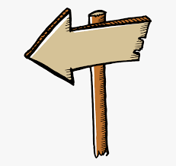

The Sign Posts of the New Testament

Sign Post #1: _________ and Cross

Sign Post #2: __________ and Commission

Sign Post #3: Punishment and _____________

TWO SECTIONS IN CHURCH AND COMMISSION

#1 – The Church’s Witness – Acts

#2 – The Church’s Writings – Romans-Jude

What is the Church?

#1 – The Church’s Witness – Acts

A. Introductory Comments concerning the book of Acts

1. Its title:

2. It takes place in a transitional period of time.

3. We are given progress reports along the way.

4. One-third is sermons.

5. The Key verse Acts 1:8 gives us the outline of the book

________ - The Church’s witness in Jerusalem
________ - The Church’s witness in Judea and Samaria
________ - The Church’s witness to the ends of the earth
-11-
B. A Walk Through the Book of Acts:

1. The Church’s Witness in Jerusalem – Act 1-7

a. The Church is born – Acts 2

b. The Church’s first progress report – Acts 2:42-47

The Early Church Devoted Themselves To . . . – Acts 2:42
1.
2.

3.

4.

c. The Church’s problems – Acts 3-7

2. The Church’s Witness in Judea and Samaria:

3. The Church’s Witness to the ends of the earth:

-12-

